BEFORE/AFTER TOPIC SCREENSHOTS

STUDENT NAME: GIDEON EWA
BASELINE Q RESPONSE
Three questions were posed to Q Chat and the responses were recorded. The responses served as a baseline before Topic was configured for Q chat. The screenshots are shown below:

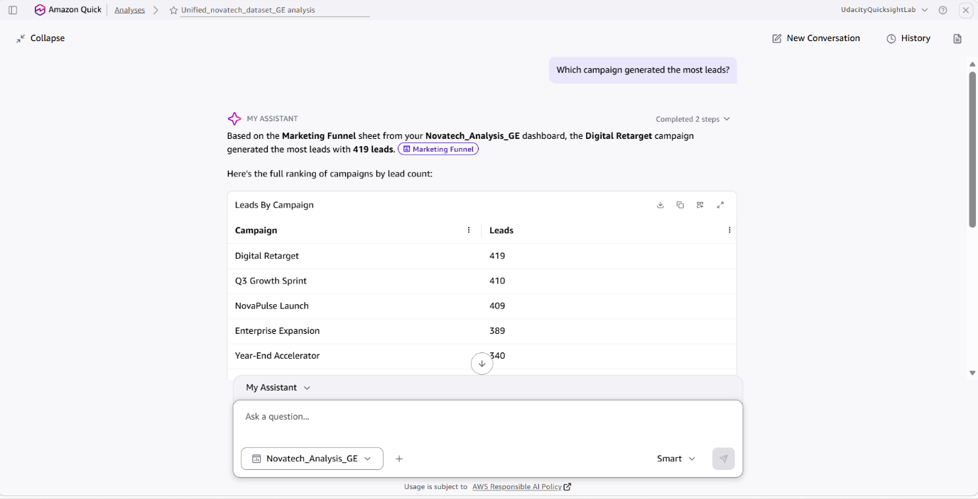

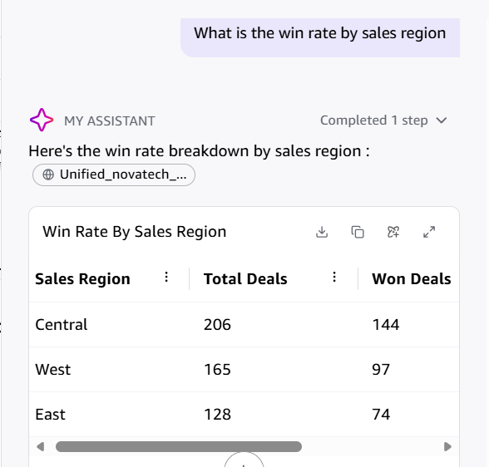
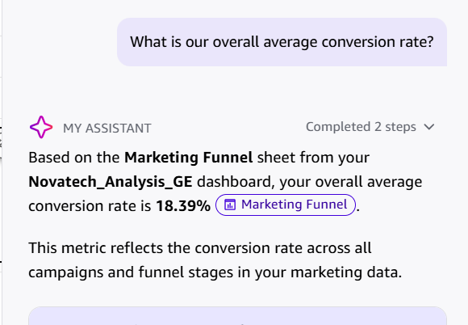

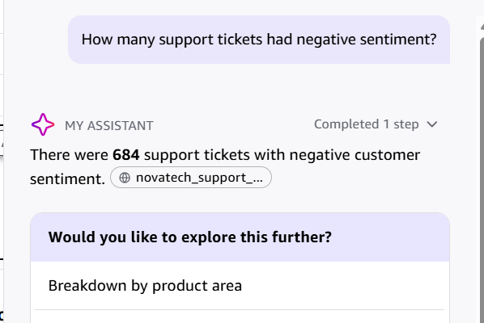

AFTER TOPIC SCREENSHOT
After Topic was configured, the same questions were posed to Q chat and the following responses were captured.
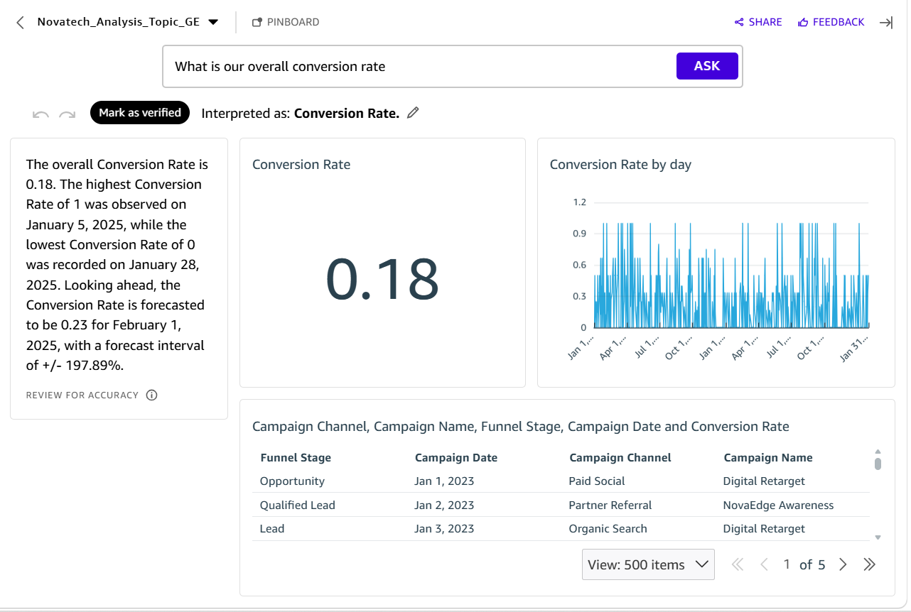

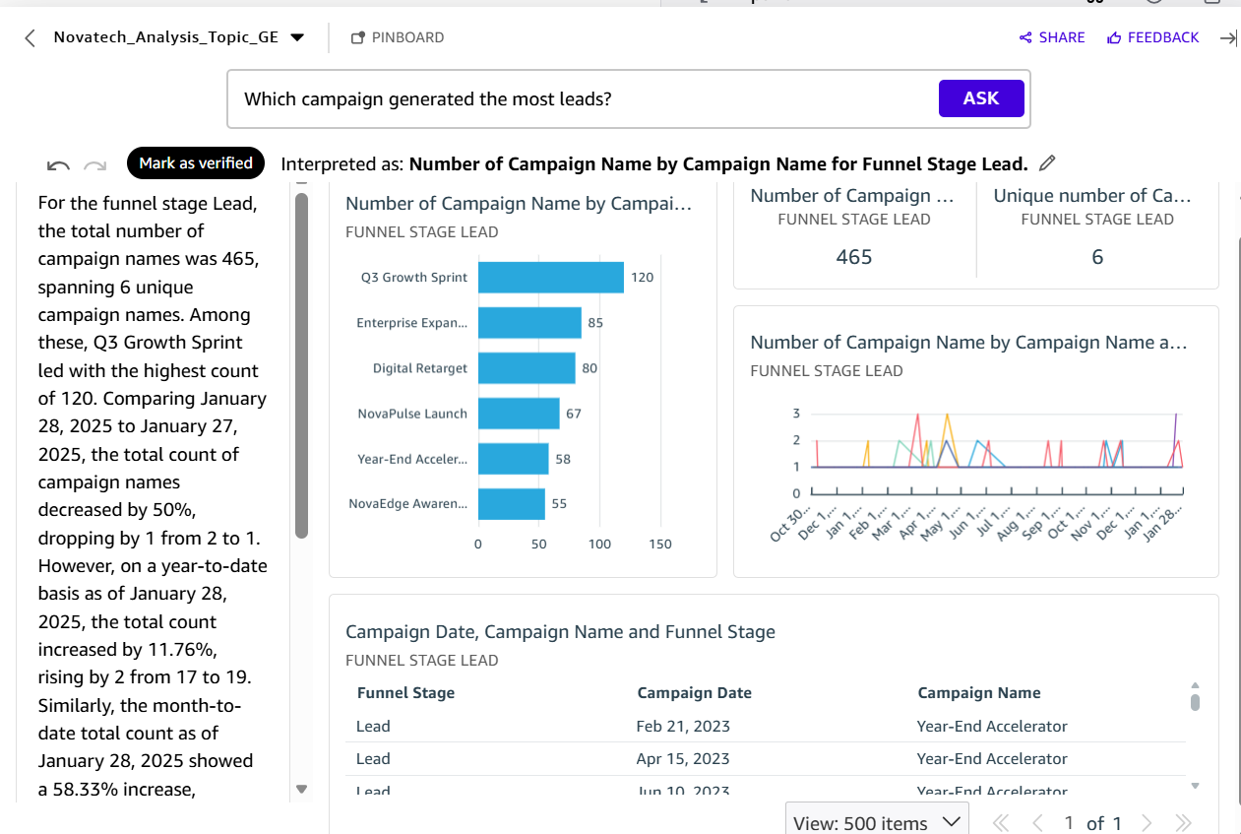

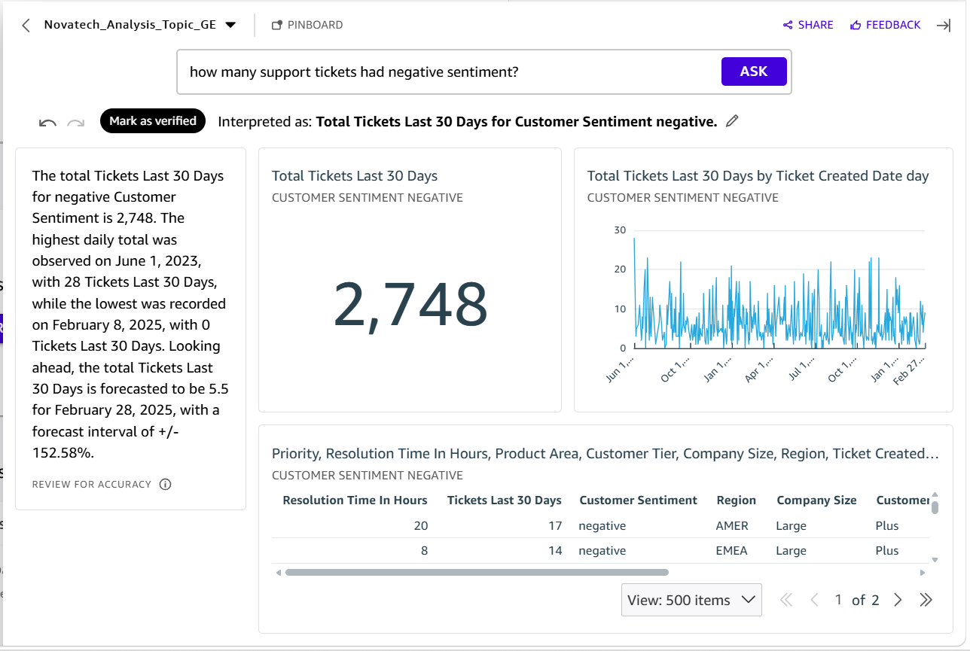

Student Name: Gideon Ewa
SCREENSHOTS OF FILTERED AND UNFILTERED DASHBOARD

MARKETING FUNNEL
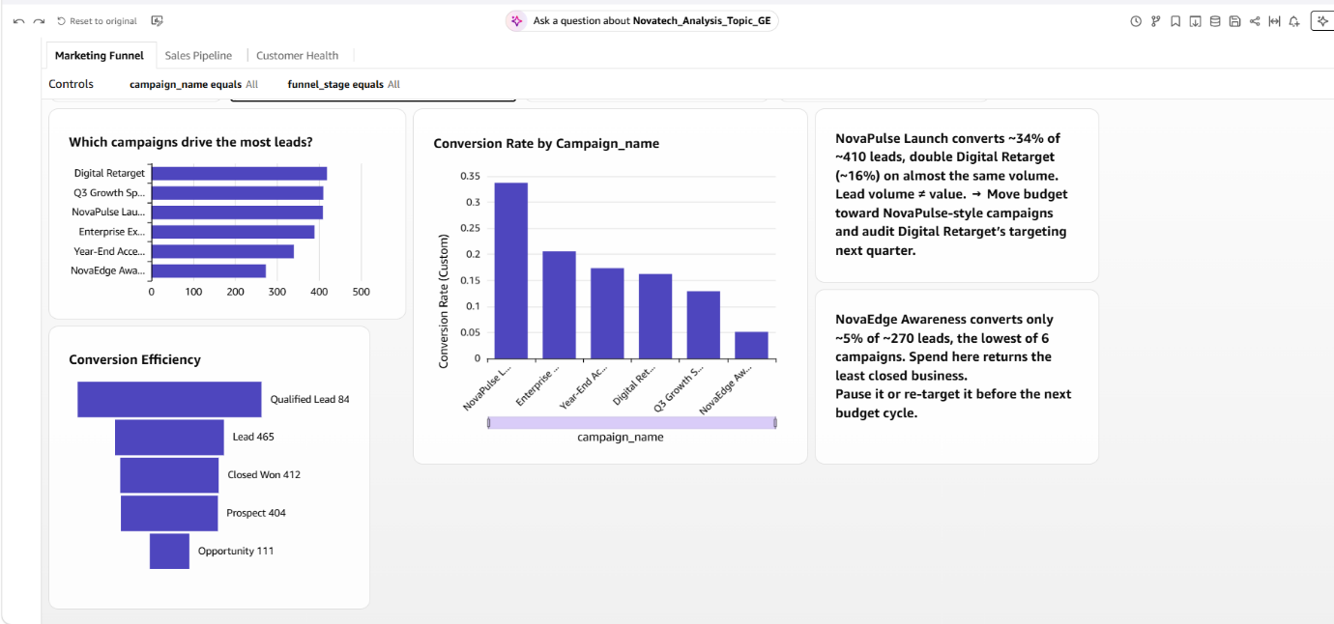
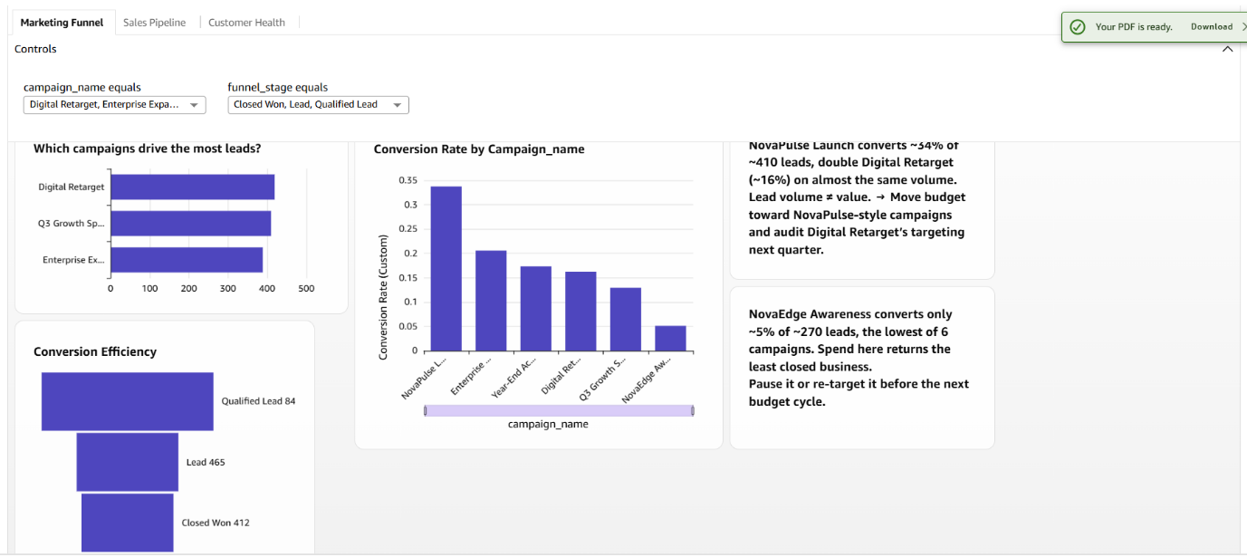

SALES
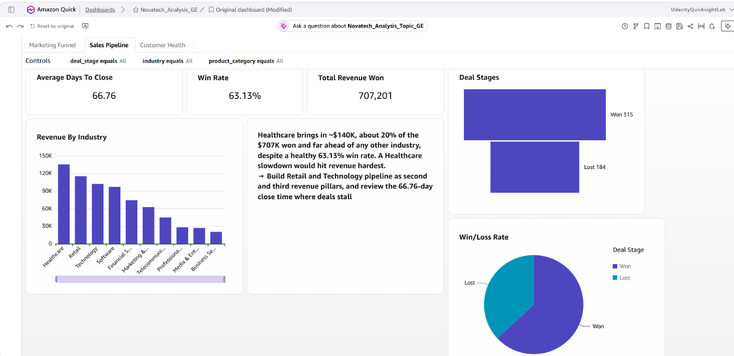
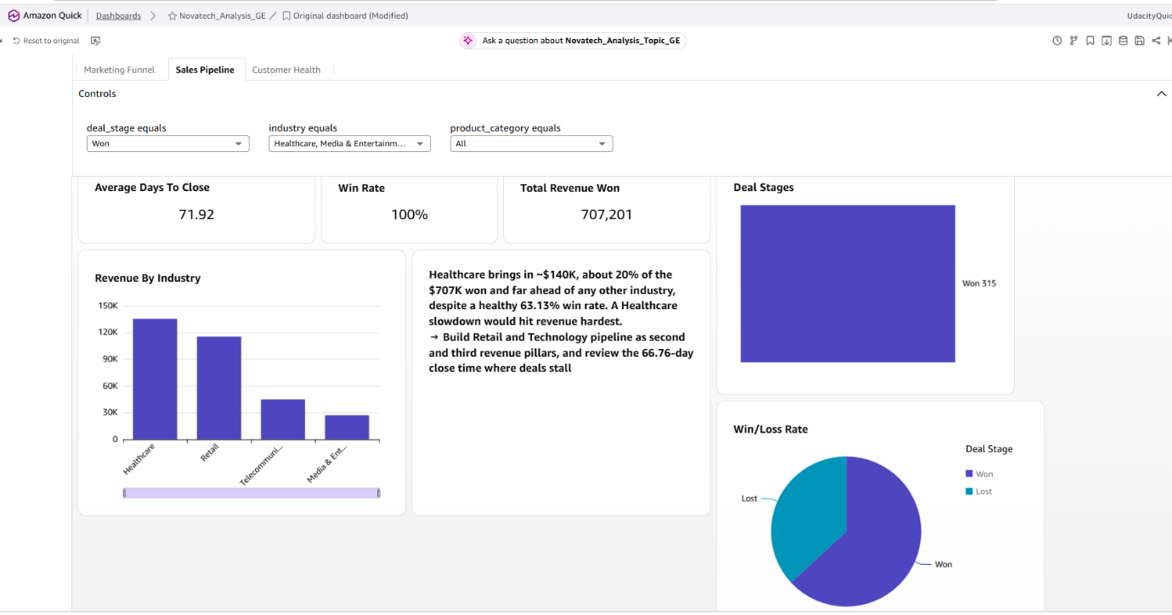

CUSTOMER HEALTH
